DECISIONS DELEGATED TO OFFICERS

Decision title: | Award of contract to Kek Tech Limited for the Energy Superhub Oxford data evaluation project
Decision date: | 06/04/22
Source of delegation: | This decision was delegated to officers under Part 4.4 of the Council’s Constitution: all executive functions except those in Part 4.5, 4.6 and 4.7 are delegated to the officers in the senior management structure.
What decision was made? | To award a contract to Kek Tech Limited for the completion of data analysis and data monitoring system provision as part of the Energy Superhub Oxford Data Evaluation project. The value of the contract is £20,000.
Purpose: | To provide a data analysis and monitoring system as part of the Energy Superhub Oxford project.
Reasons: | The initial works were completed by contractor Gabriel Yoong, with assistance from the founder of Kek Tech. Gabriel Yoong is no longer able to complete the project. Due to the complexity and unique intricacies of the project it is hugely time and cost effective for Kek Tech Limited, which is already familiar with the project, to complete the remainder of the work. The contractor rates provided are very competitive and the project must be completed to comply with the Innovate funding.  This was initially set as 2 months’ work however, several months later, due to internal ICT constraints and external software provider issues, the work is still ongoing.
Decision made by: | Mish Tullar, Head of Corporate Strategy
Other options considered: | The option to choose not to deliver the programme was available, but was effectively ruled out as this would not comply with Innovate funding and would undo several months of work.
Documents considered: | None
Key or Not Key: | Not key
Wards significantly affected: | None
Declared conflict of interest: | None
This form was completed by:  Name & title:  Date: | Kristina Mould  Capital Programme Project Manager  05/04/22

Approval checklist

Approver | Name and job title | Date
Decision maker | Mish Tullar, Head of Corporate Strategy  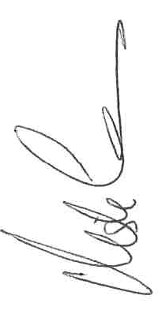 | 06/04/22

